**SPRINT III**

|  |  |
| --- | --- |
| Team ID | PNT2022TMID33953 |
| Project Name | Airlines Data Analytics for Aviation Industry |

**DASHBOARD:**

Dashboards are a collection of widgets that give you an overview of the reports and metrics you care about most. Dashboards let you monitor many metrics at once, so you can quickly check the health of your accounts or see correlations between different reports. Dashboards are easy to create, customize and share

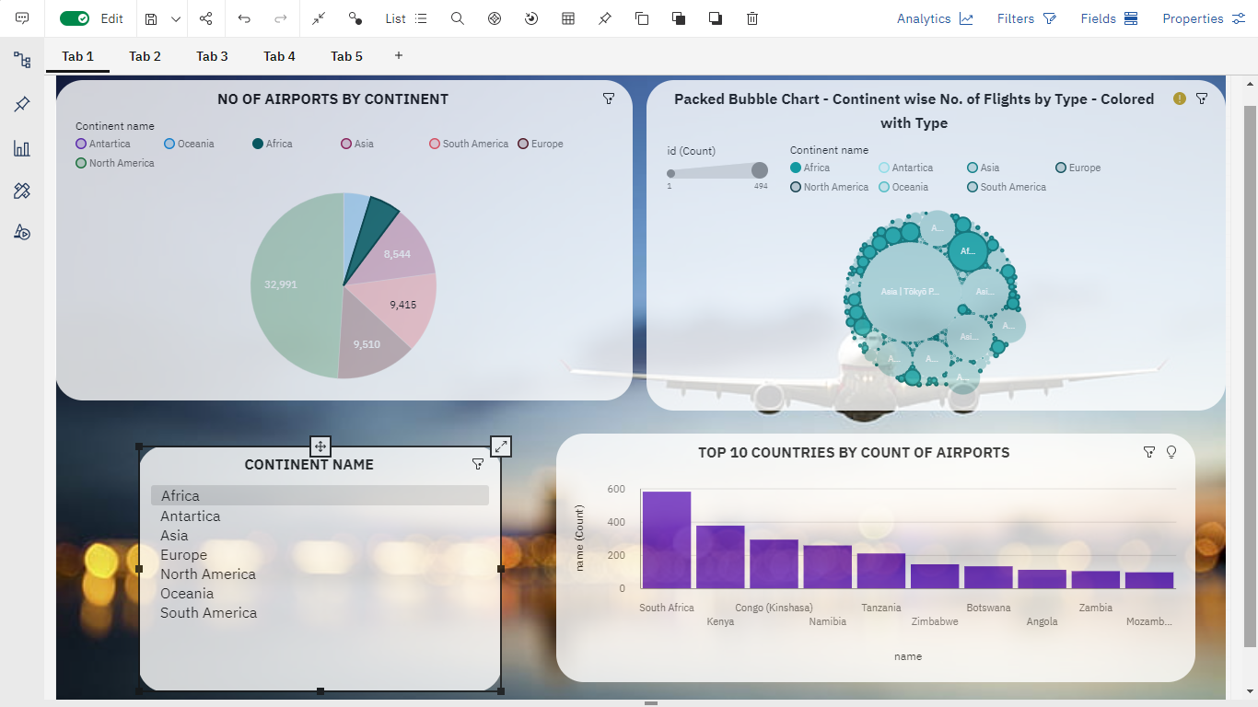

An airports officials can view the top 10 countries by the count of airport in a continent by just clicking the any of the continent names from the continent name list (AFRICA) , also the pie chart and packed bubble chart can also be viewed for the same.

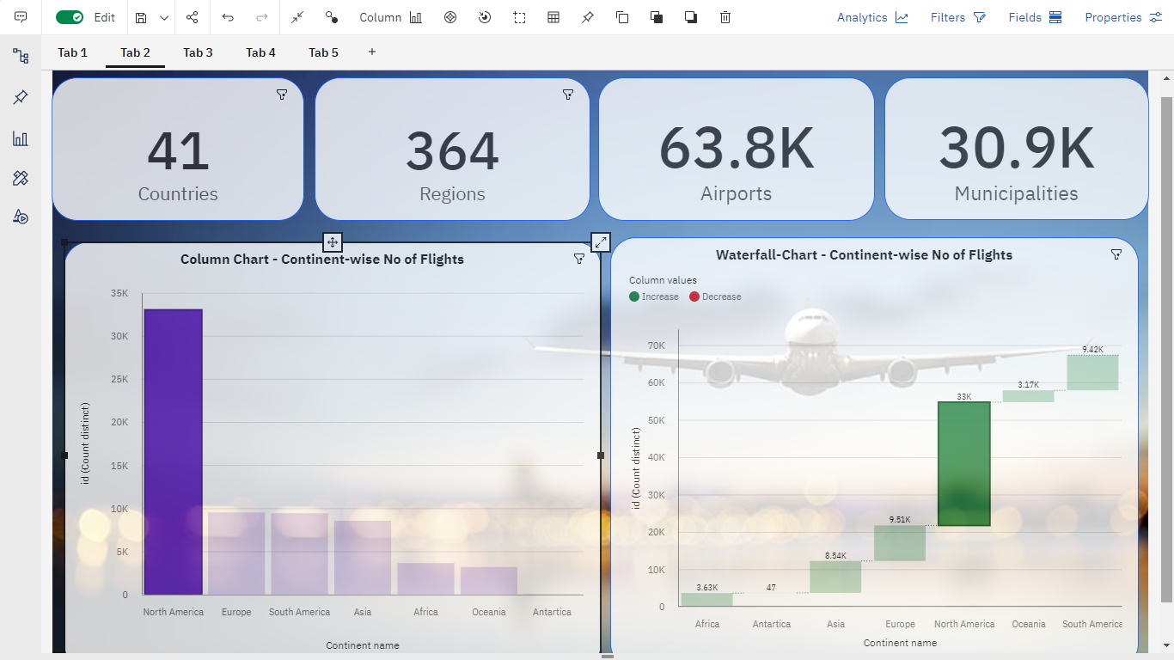

An airport officials can view the summary of no. of countries along with its regions , airports and their respective municipalities in the continent by clicking the particular continent from the column chart or waterfall chart.

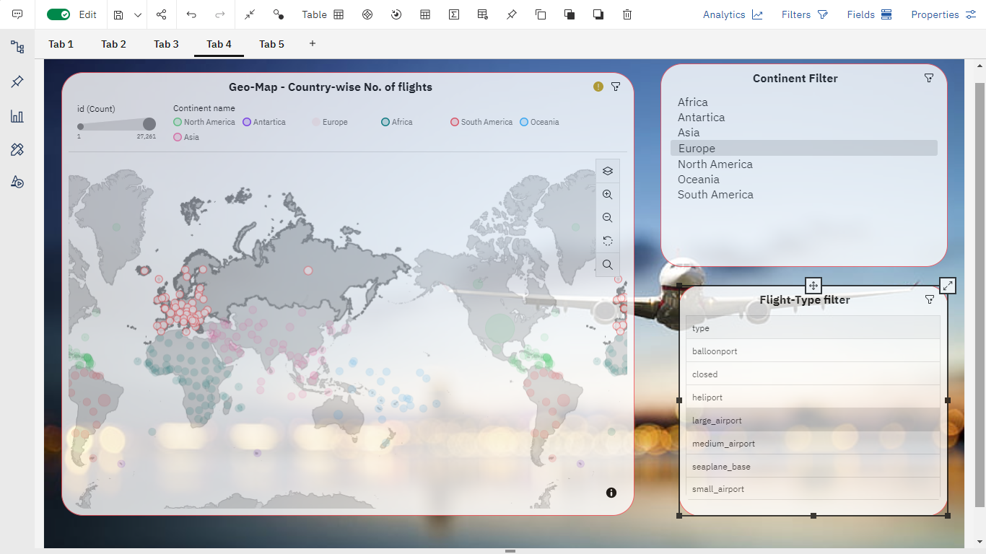

An airport officials can view Geo-Map showing the no. of airports based on continent name and flight type by clicking the needed continent name from the continent filter list and also by clicking the needed airport type from the Flight-Type filter.

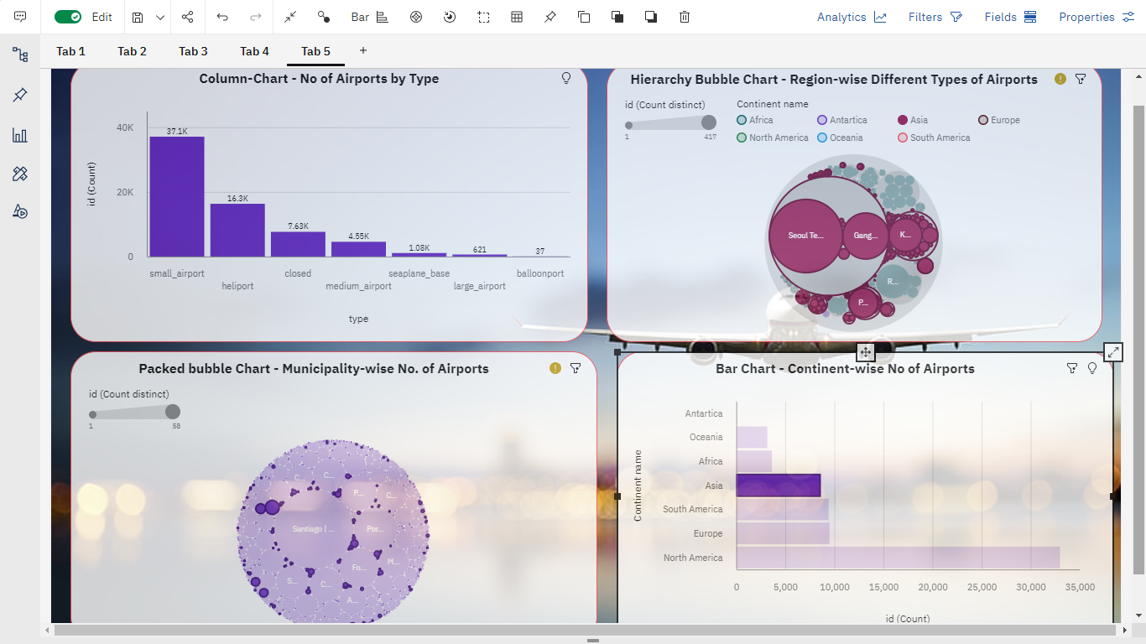

An airport officials can view the column chart(No. of airport by types) , Hierarchy bubble chart(Region-wise Different types of airport) and packed bubble chart(Municipality-wise No. of airports) by clicking the needed continent from the bar chart.